**Top Personal Finance Concerns: Analysis Based on**

**The Reddit Data**

MACSS Jinfei Zhu ([jinfei@uchicago.edu](mailto:jinfei@uchicago.edu))

Introduction

In 2017, a Federal Reserve survey(Federal Reserve, 2018) finds almost 40% of American adults wouldn't be able to cover a $400 unexpected emergency expense with cash, savings or a credit-card charge that they could quickly pay off, saying that they would either not be able to cover it or would cover it by selling something or borrowing money. Why do people in the United States, the most powerful country in the world, so ill-prepared for? What's the heaviest financial burden on people? What are the topics that people who seek financial security talks every day? Do these topic change over time?

In the past, to answer these questions, we may have to turn to the power of survey to ask each interviewee questions individually, but now there are many people discuss their financial concerns online and post their thoughts, questions and suggestions online, in the subreddits from Reddit website. So, we can scrape the text data and do some content analysis including counting, clustering and word embedding to dig the information behind the content data.

In Macroeconomics, there is a formula showing the equilibrium of output and input of economics yields:

Y = C + I + G + NX

(Total economic output = Consumption + Investment + Government spending + Net Export). It shows that the consumption and investment are individual activities that constitute of our society. Therefore, studying the personal finance concerns will give us better insight about macroeconomics about individual’ financial behaviors, including consumptions, debts, loans, investments, insurance and retirement planning. My study will report the most common financial burden on people, and the time trend of the changes most-discussed topics. In this way, people can know what bothers us and if the things that bother us change over time.

Here is the structure of my analysis:

First, data collection: Use Reddit API and the Python Reddit API Wrapper (PRAW) to scrape the data from Personal Finance, Wall Street Bets and Investing subreddit so we can to tokenize, normalize and vectorize the text data.

Second, counting the words and phrases: count the frequency of key words and n-grams in reddit post, do part-of-speech tagging and find the difference from personal finance reddit and other finance-related subreddit.

Third, clustering and topic modelling: Do Latent Dirichlet Allocation topic modelling for texts of subreddits.

Fourth, word embedding and projections to see the more information about the project.

Data

Reddit is the social news platform, web content rating and discussion website, recently including livestream functions. In reddit, there are many subreddits which are forums to a specific topic. People's online discussion is a good reflection of their real-life concerns and thinking.

I scraped Reddit articles from different subreddits.

* Personal Finance
* Investing (Now name: lose money with friends!)
* Wall Street Bets

Personal Finance subreddit (r/personal finance) is created on Feb 9, 2009, right after the 2008 financial depression. It has 14.4 million members and usually have 14.9k members online. It’s a very active and large subreddit compared to other relatively subreddit and well-organized. Every hour there are many new discussions about topics such as debts, loans, housing, auto, insurance, investing, retirement, taxes, budgeting and income. People post their concerns, seek for advice, or share personal experience. There is a very detailed wiki for this subreddit (Reddit, 2021) listing a summary of suggestions for different age of people. Therefore, I think it would be a good choice to scrape text data from for my personal finance concern analysis.

Wall Street Bets subreddit (r/wallstreetbets) is created at Jan 31, 2012, with 9.6 million members and 255k daily online active members. It’s smaller compared to Personal Finance subreddit in terms of members, but much more active in terms of daily online members. Participants would discuss stock and option trading strategies on it. It becomes popular and famous for its aggressive trading strategies and role in the GameStop short squeeze that caused losses on Wall Street hedge funds short sellers up to US$70 billion in a few days in early 2021. Perhaps due to its popularity, a lot of posts on this reddit are news videos, so the text content from this subreddit is slightly less than other two subreddits.

Investing subreddit (r/investing) is created at March 15, 2008, the oldest one among these three subreddit. It changed its name to ‘lose money to your friend because only after few months of its creation, the stock market crashed in 2008. But it only has 1.8 million members and 9k members online. Compared to Wall Street Bets, it’s a place to start if members don’t know anything about investing and begin to learn it. We add this subreddit into our corpora to compare the difference of content across different subreddits.

People are anxious about money, paying debt and managing their asset and making investments. Most people who post articles on Reddit are young people, many of them are 20-30 (many people reveal their age in posts on Personal Finance discussion) and it's interesting to learn the consumption and investment patterns of these young people. They are a large group of anxious young people--we can find students who just got their first job start to consider paying back student loan, buying houses or cars with loans, starting to think of taking care of aging parents, for the first time in their life. They ask advice from others on online platform to make finance-wise decisions and many kind people offer their kind suggestions to others.

Here are some examples of the posts:

Personal Finance

**Title: “**You are not "family" to your company. If you have an opportunity to better yourself, take it. They will do the same when it comes to cutting ties with you.”

**Text:** “People tend to feel a sense of guilt when it comes to leaving a job like they owe them or their coworkers something. That is because America preaches this "family" culture that we are such a strong team all working together. In reality, if they need to close your entire division, they will do it without hesitation. If they can outsource something cheaper, they will do it. You do not owe them anything and if you see a better opportunity for yourself or your family, please take it and make your own financial future.”

Wall Street Bets:

**Title:** “CLASS ACTION AGAINST ROBINHOOD. Allowing people to only sell is the definition of market manipulation. A class action must be started, Robinhood has made plenty of money off selling info about our trades to the hedge funds to be able to pay out a little for causing people to lose money now”

**Text:** “LEAVE ROBINHOOD. They don’t deserve to make money off us after the millions they caused in losses. It might take a couple of days, but send Robinhood to the ground and GME to the moon.”

Investing;

**Title:** “Robinhood and other brokers literally blocking purchase of $GME, $NOK, $BB, $AMC; allow sells”

**Text:** “See title. Can't buy these stocks on RH, but can sell. What the hell is this? How is this legal?”

Top 20 words

|  |  |  |  |  |  |  |  |  |
| --- | --- | --- | --- | --- | --- | --- | --- | --- |
|  | word | count |  | word | count |  | word | count |
| 1 | $ | 2236 | 1 | $ | 295 | 1 | $ | 1677 |
| 2 | money | 1153 | 2 | gme | 285 | 2 | > | 902 |
| 3 | credit | 1006 | 3 | shares | 234 | 3 | market | 854 |
| 4 | time | 872 | 4 | 🚀 | 217 | 4 | company | 629 |
| 5 | pay | 834 | 5 | short | 191 | 5 | stock | 549 |
| 6 | edit | 811 | 6 | people | 163 | 6 | price | 536 |
| 7 | account | 809 | 7 | edit | 155 | 7 | said | 470 |
| 8 | like | 771 | 8 | market | 155 | 8 | year | 462 |
| 9 | know | 694 | 9 | like | 148 | 9 | people | 455 |
| 10 | people | 692 | 10 | buy | 147 | 10 | like | 434 |
| 11 | work | 627 | 11 | stock | 139 | 11 | time | 407 |
| 12 | years | 617 | 12 | money | 135 | 12 | = | 372 |
| 13 | year | 590 | 13 | price | 131 | 13 | money | 360 |
| 14 | job | 581 | 14 | know | 119 | 14 | billion | 358 |
| 15 | 2 | 580 | 15 | fucking | 118 | 15 | companies | 355 |
| 16 | car | 572 | 16 | time | 112 | 16 | years | 329 |
| 17 | going | 569 | 17 | going | 101 | 17 | shares | 319 |
| 18 | bank | 549 | 18 | sell | 93 | 18 | value | 318 |
| 19 | got | 541 | 19 | hedge | 90 | 19 | short | 307 |
| 20 | want | 539 | 20 | want | 88 | 20 | stocks | 295 |

We find many finance-related words, the dollar sign is the most frequent word and the second is the word money, which is definitely the center of the discussion. We also have a lot of talks about credit and paying, as well as bank account and many time related words such as "year" and "month" "time". People also talk about getting a job (perhaps due to the surged unemployment rate during pandemic and car (cars are really important in American cultures, such as car insurance and car loan.

We can also look at the top words in Wall Street Bets and Investing subreddit.

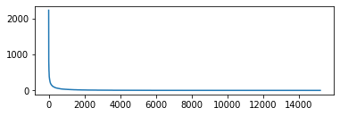

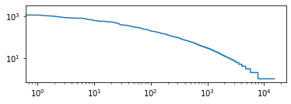

ests/new?ticket_form_id=38824 banks student loans credit reports debt collector

companies to match their employees student loan repayments in the same way com

rding to the article employees with student loan debt accumulate 50 less wealth

by age 30 than their peers without student loan debt i think most of us with s

t loan debt i think most of us with student debt have at one point or another f

you would be able to make qualified student loan payments and have your company

ch month you made a payment on your student loan this does n't hurt people with

g my way out of that lovely college student debt i incurred over four years and

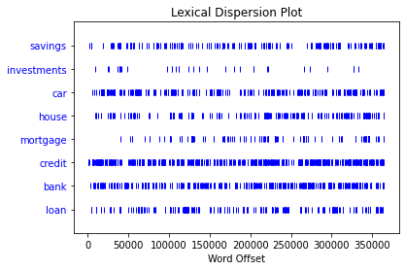

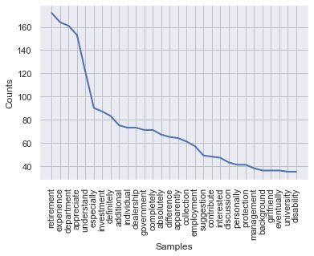

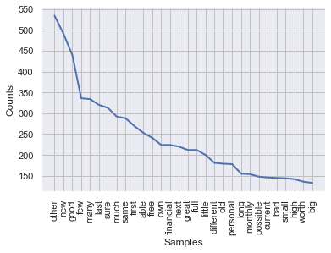

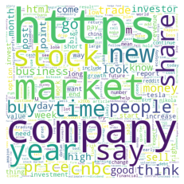

|  |  |  |  |  |  |  |
| --- | --- | --- | --- | --- | --- | --- |
|  | bigram | likelihood ratio | bigram | student t | trigram | student t |
| 0 | (credit, card) | 2643.262 | (credit, card) | 18.42461 | (credit, card, debt) | 6.16226 |
| 1 | (r, personalfinance) | 1549.953 | (student, loan) | 12.52463 | (r, personalfinance, wiki) | 5.830942 |
| 2 | (student, loan) | 1459.923 | ($, month) | 12.26468 | (domain, core, finance) | 5.477223 |
| 3 | (emergency, fund) | 867.1817 | (feel, like) | 10.5862 | (finance, domain, core) | 5.477223 |
| 4 | (wells, fargo) | 819.7325 | (r, personalfinance) | 10.42911 | (=, plubok8lzixw90vxgryjqwfpf4bz, tyegn) | 5.099018 |
| 5 | (feel, like) | 772.0689 | (year, ago) | 9.576361 | (economic, finance, domain) | 4.795828 |
| 6 | (credit, score) | 678.7974 | (edit, thank) | 9.389019 | (pay, credit, card) | 4.679945 |
| 7 | (year, ago) | 640.507 | (credit, score) | 9.319235 | (use, credit, card) | 4.356131 |
| 8 | ($, month) | 628.442 | (m, sure) | 9.288765 | ( , $) | 4.245525 |
| 9 | (debit, card) | 571.5363 | (bank, account) | 9.19252 | (long, story, short) | 4.123074 |
| 10 | (=, plubok8lzixw90vxgryjqwfpf4bz) | 563.0308 | (saving, account) | 8.707325 | (credit, card, company) | 4.11881 |
| 11 | (interest, rate) | 503.7708 | (emergency, fund) | 8.584085 | (file, police, report) | 3.872937 |
| 12 | (bank, america) | 503.4188 | (m, go) | 8.43796 | (thank, take, time) | 3.869329 |
| 13 | (domain, core) | 496.1812 | (year, old) | 8.221385 | (m, year, old) | 3.869165 |
| 14 | (long, term) | 495.7307 | (pay, $) | 7.954511 | (social, security, number) | 3.741621 |
| 15 | (m, sure) | 489.9854 | (debit, card) | 7.823408 | (m, gon, na) | 3.605541 |
| 16 | (gon, na) | 485.1064 | (interest, rate) | 7.750402 | ($, credit, card) | 3.58576 |
| 17 | (saving, account) | 453.3198 | (let, know) | 7.747792 | (=, =, =) | 3.46399 |
| 18 | (edit, thank) | 448.8481 | (save, money) | 7.523519 | (open, credit, card) | 3.462296 |
| 19 | (plubok8lzixw90vxgryjqwfpf4bz, tyegn) | 446.6506 | (long, term) | 7.310689 | (pay, student, loan) | 3.46094 |

## Distributional distances

If we want to compare different corpora, we need a distance or divergence that compares the two distributions.

We will use the:

+ Kullback-Leibler (KL) divergence

+ $\chi^2$ divergence

+ Kolmogorov-Smirnov (KS) distance

+ Wasserstein distance

### Kullback-Leibler and $x^2$ divergences ###

KL and $\chi^2$ divergences are members of the broader <a "href=https://en.wikipedia.org/wiki/F-divergence" target="_blank">$f$-divergence</a> family, a function of $D_f (P || Q)$ that calculates the difference between two probability distributions P and Q. The KL $f(t)$ is $ t \text{ log } t $, while the $\chi^2$ is $t^2-1$. KL comes from information and $\chi^2$ from measure theory. As such, the KL divergence computes the relative entropy between two distributions--how they differ in bits, while the $\chi^2$ whether the same statistical inferences can be drawn from them both.

Specifically, given two discrete probability distributions $P$ and $Q$, the Kullback-Leibler divergence from $Q$ to $P$ is defined as:

$D_{\mathrm{KL}}(P\|Q) = \sum_i P(i) \, \log\frac{P(i)}{Q(i)}$.

The [scipy.stats.entropy()](https://docs.scipy.org/doc/scipy/reference/generated/scipy.stats.entropy.html) function does the calculation for you, which takes in two arrays of probabilities and computes the KL divergence. Note that the KL divergence is in general not commutative, i.e. $D_{\mathrm{KL}}(P\|Q) \neq D_{\mathrm{KL}}(Q\|P)$ .

Also note that the KL divernce is the sum of elementwise divergences. Scipy provides [scipy.special.kl_div()](https://docs.scipy.org/doc/scipy/reference/generated/scipy.special.kl_div.html#scipy-special-kl-div) which calculates elementwise divergences for you.

The $\chi^2$ Divergence is defined as:

$D_{\mathrm{\chi^2}}(P\|Q) = \sum_i \left(\frac{P(i)}{Q(i)}-1\right)^2$.

This is also noncommutative, and the code can be drawn directly from scipy.

### Kolmogorov-Smirnov ###

The two-sample Kolmogovorov-Smirnov test statistic calculates the distance between the cumulative distribution function of the two distributions to be compared, and, along with the $x^2$ divergence, is among the most common approaches two calculating a distance in statistics. It can be interpreted as a test of whether two distributions are drawn from the same underlying distribution. As with the others, the code is readily available in scipy.

### Wasserstein Distance ###

When this is computed on a Euclidian metric structure (e.g., numbers of words), this is also known as the earth mover’s distance, because it can be seen as the minimum amount of "work" required to transform $P$ into $Q$, where "work" is measured as the amount of distribution weight that must be moved, multiplied by the distance it has to be moved.

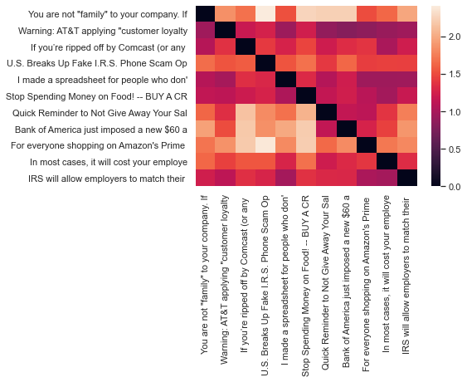

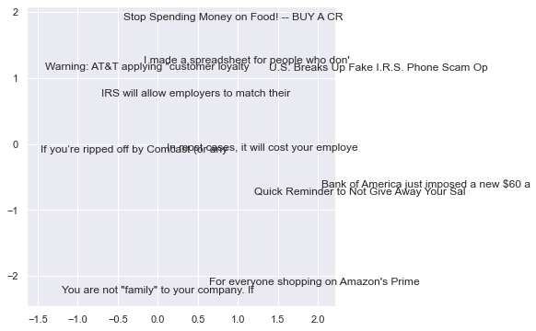

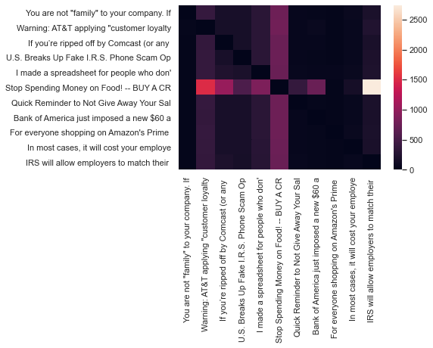

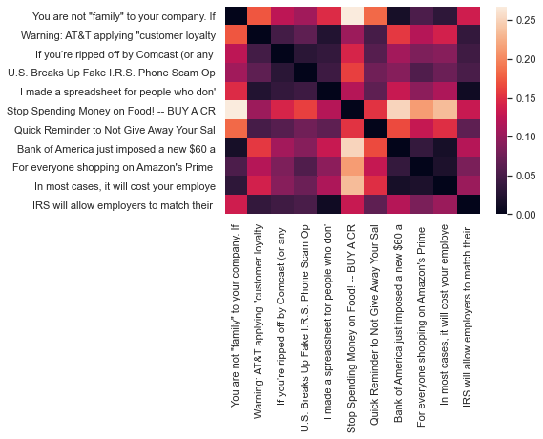

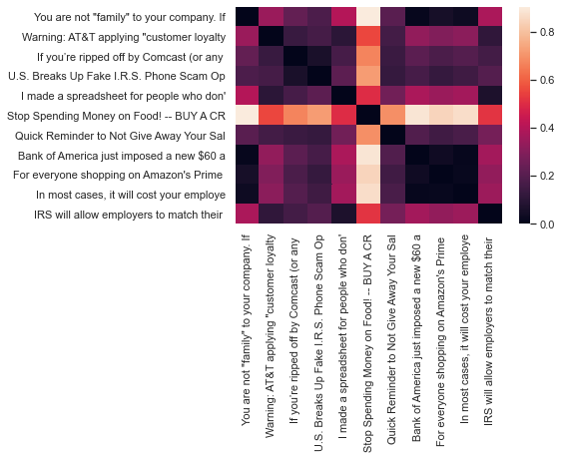

# Discovering Patterns, Clusters, and Topics

What do we want to do here? We want to do vectorization, i.e., converting texts into numerical features (vectors) as required by machine learning algorithms. And this is what feature_extraction module does: to extract features from texts in a format as required by ML algorithms. feature_extraction module has four classes: CountVectorizer, DictVectorizer, TfidfVectorizer, and FeatureHasher. Here, we use CountVectorizer, but we'll also use TfidfVectorizer as well below.

There are various strategies by which we extract features. Here, we use CountVectorizer, and, in particular, we use 'Bag of Words' representation. In other words, the features we hope to extract from the texts are each individual token occurrence frequency. We simply count the the occurrence of each token in each document. So, here, we get a document-term-matrix, in which documents are characterized by the occurrences of tokens. Other forms of features, such as the relative position information of words, are ignored. We'll see other types of representations and strategies as well soon, such as N-gram (by the way, we can do n-gram with CountVectorizer. CountVectorizer class takes a set of parameters, such as analyzer, which you can specify the n-gram).

tf-idf data

|  |  |  |
| --- | --- | --- |
|  | **word** | **tf-idf** |
| **0** | people | 0.113324 |
| **1** | tend | 0.183513 |
| **2** | to | 0.096107 |
| **3** | feel | 0.0947 |
| **4** | sense | 0.089033 |
| **5** | of | 0.107934 |
| **6** | guilt | 0.060562 |
| **7** | when | 0.060865 |
| **8** | it | 0.111935 |
| **9** | comes | 0.097494 |

# Flat clustering with K-means

介绍一下 k-means和homogeneity completeness这些

Homogeneity: 0.504

Completeness: 0.428

V-measure: 0.463

Adjusted Rand Score: 0.513

We can find that our data has homogeneity and completeness all nearly 0.50, which means that there is no perfect alignment. No cluster contains all texts from one class, and no cluster is exacterly one class.

According to the Adjusted Rand Index, our clusters are much better than a random assignment, which ARI is 0 (so compared to 0, 0.513 is a satisfactory value).

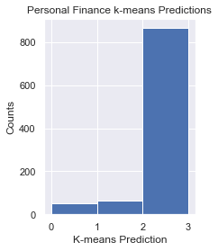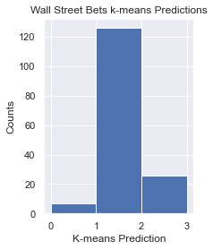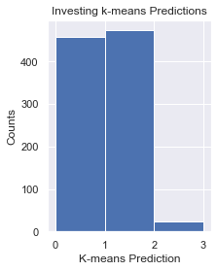

We found that, almost all texts in personal finance category are in cluster 2, which means they are really different (far) from others.

80% posts from wall street bets are in cluster 1, 16.7% of its posts are in cluster 2, so we have the conclusion that usually posts from wall street bets are different from others, but some times they could be devided in cluster 2 (which means they have personal finance problem such as tax, debt or retirement), and they haven't realize subreddit 'personal finance' is the best choice

However, for category 'investing', the k-means cluster label is really unstable and inconsistent, in 10 posts, there are 4 in cluster 0, 5 in cluster 1,

|  |  |  |
| --- | --- | --- |
| Cluster 0 | Cluster 1 | Cluster 2 |
| com | market | just |
| https | stock | money |
| www | https | credit |
| cnbc | com | account |
| html | gme | edit |
| 2020 | stocks | ve |
| 2019 | price | don't |
| 2018 | company | pay |
| news | year | job |
| http | people | card |

### Plot clusters & features after reducing with PCA

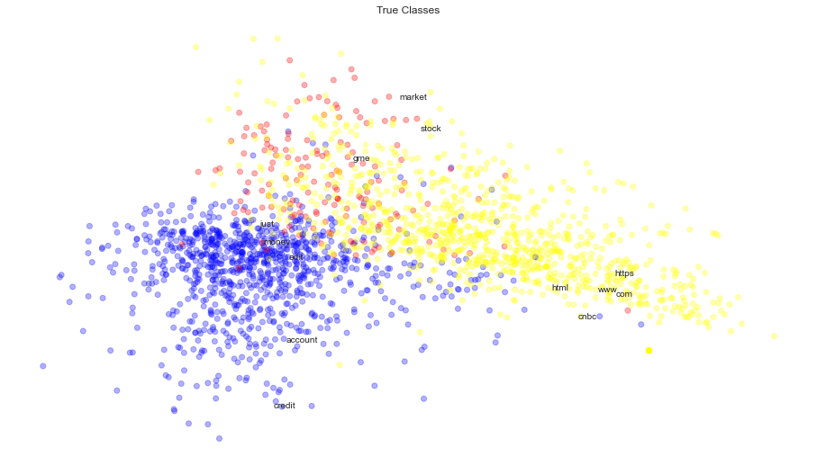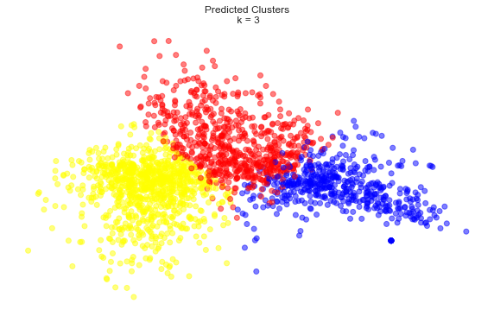

We can find that, similar colors in predicted clusters are nearer to each other. Maybe bacause the size of dataframes are not equal, (there are so many posts in wall street bets subreddit lack content--they only use photo, video, gif or emoji), many topics are related such as planning and budgeting. So in manual labeling they are a lot of overlaps but in machine learning, they could be seperated better.

### Identify the optimal cluster number with Silhouette analysis

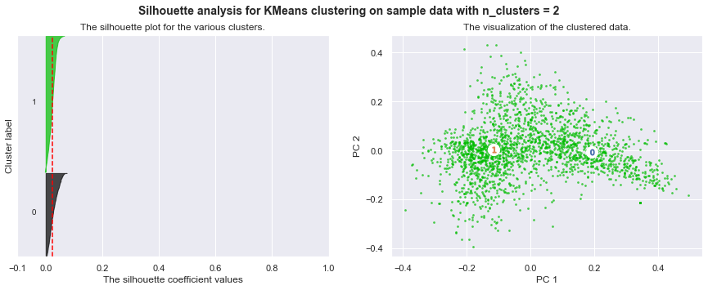

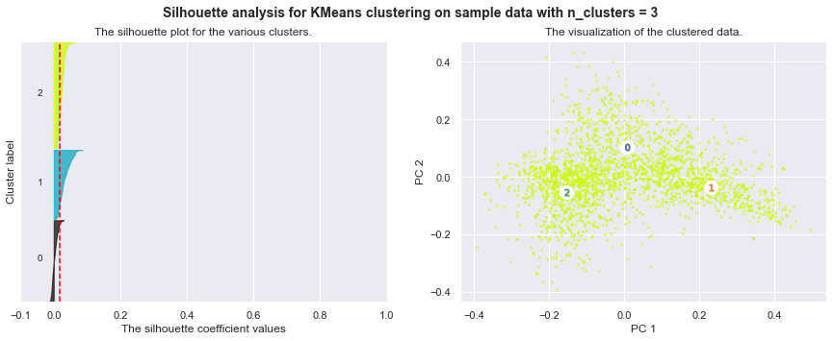

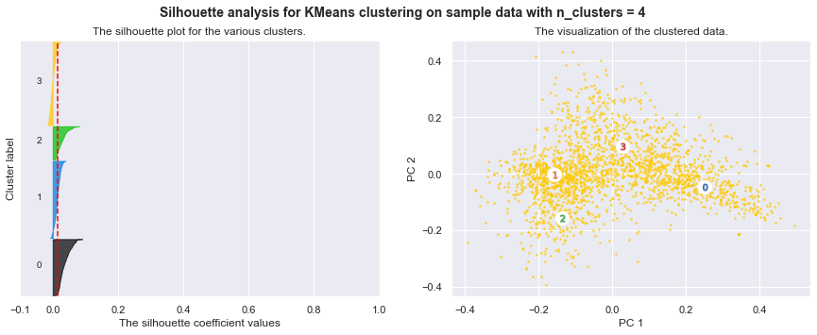

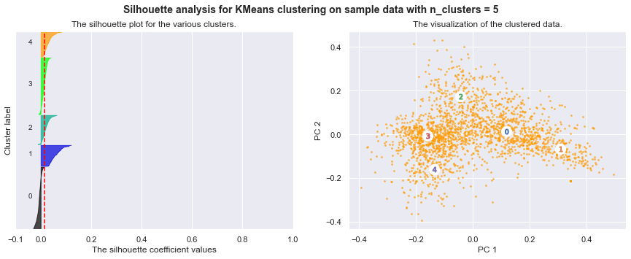

*method='single'*, *metric='euclidean'*, distance

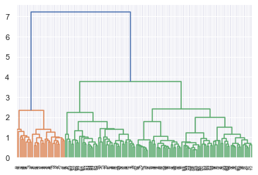

Average distance

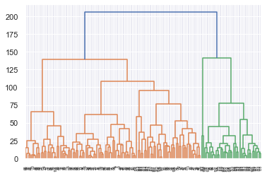

Correlation distance

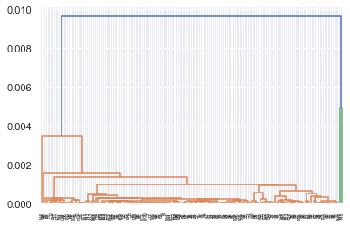

Cosine distance

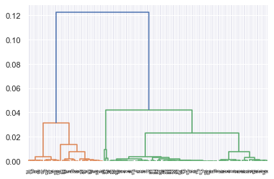

|  |  |  |
| --- | --- | --- |
|  | k-means | Ward |
| Homogeneity | 0.504 | 0.304 |
| Completeness | 0.428 | 0.268 |
| V-measure | 0.463 | 0.285 |
| Adjusted Rand Score | 0.513 | 0.367 |

## Topic Modeling

|  |  |  |  |  |  |  |  |  |  |
| --- | --- | --- | --- | --- | --- | --- | --- | --- | --- |
| topic_0 | topic_1 | topic_2 | topic_3 | topic_4 | topic_5 | topic_6 | topic_7 | topic_8 | topic_9 |
| 0.06 | 0.00 | 0.00 | 0.00 | 0.00 | 0.08 | 0.36 | 0.49 | 0.00 | 0.01 |
| 0.00 | 0.21 | 0.00 | 0.00 | 0.00 | 0.00 | 0.00 | 0.00 | 0.09 | 0.69 |
| 0.00 | 0.00 | 0.36 | 0.00 | 0.00 | 0.00 | 0.00 | 0.63 | 0.00 | 0.00 |
| 0.00 | 0.00 | 0.00 | 0.00 | 0.00 | 0.00 | 0.79 | 0.00 | 0.19 | 0.00 |
| 0.00 | 0.00 | 0.00 | 0.00 | 0.00 | 0.00 | 0.00 | 0.00 | 0.14 | 0.86 |
| 0.30 | 0.00 | 0.00 | 0.00 | 0.00 | 0.00 | 0.53 | 0.08 | 0.00 | 0.08 |
| 0.14 | 0.00 | 0.00 | 0.00 | 0.00 | 0.47 | 0.00 | 0.39 | 0.00 | 0.00 |
| 0.00 | 0.00 | 0.00 | 0.00 | 0.00 | 0.00 | 0.00 | 0.98 | 0.00 | 0.00 |
| 0.87 | 0.02 | 0.01 | 0.01 | 0.01 | 0.02 | 0.02 | 0.02 | 0.01 | 0.01 |
| 0.00 | 0.00 | 0.00 | 0.00 | 0.00 | 0.99 | 0.00 | 0.00 | 0.00 | 0.00 |

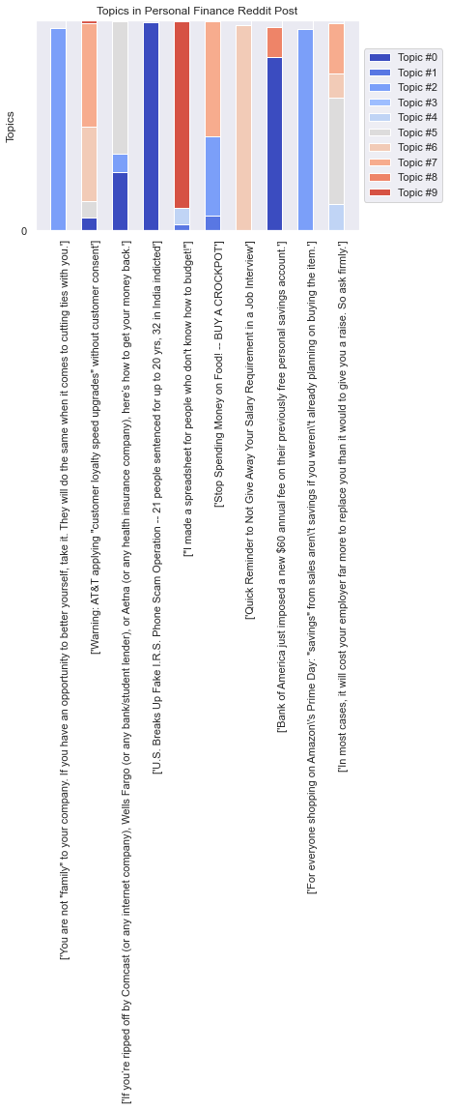

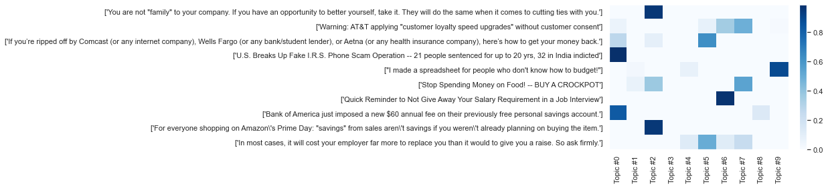

|  |  |  |  |  |  |  |  |  |  |
| --- | --- | --- | --- | --- | --- | --- | --- | --- | --- |
| Topic_0 | Topic_1 | Topic_2 | Topic_3 | Topic_4 | Topic_5 | Topic_6 | Topic_7 | Topic_8 | Topic_9 |
| credit | year | money | pay | pay | pay | work | pay | account | credit |
| pay | loan | pay | car | year | work | account | month | card | pay |
| account | know | need | tell | car | year | year | account | money | card |
| edit | work | edit | ask | money | time | pay | day | credit | year |
| know | time | year | work | work | job | time | know | pay | like |
| year | pay | bank | say | cost | company | card | time | bank | money |
| loan | want | car | time | say | think | tell | people | finance | account |
| bank | month | like | money | need | money | try | edit | year | want |
| job | money | work | year | payment | say | thank | money | spend | time |
| money | payment | say | month | income | thank | say | loan | time | month |

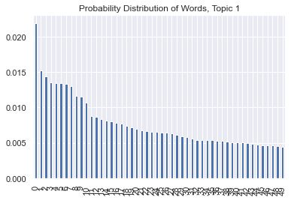

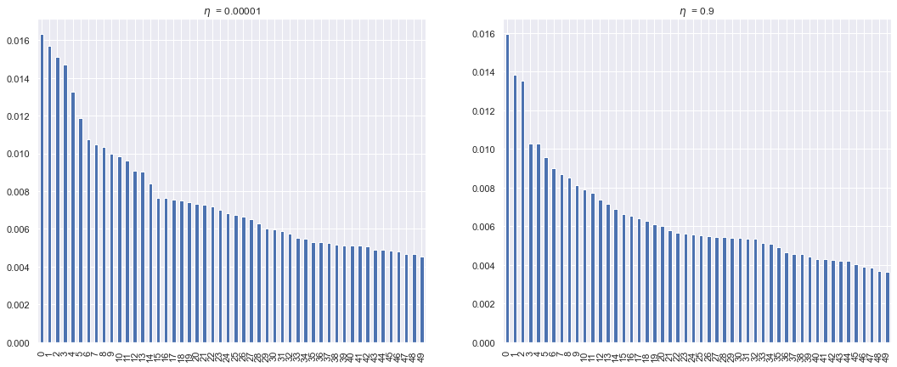

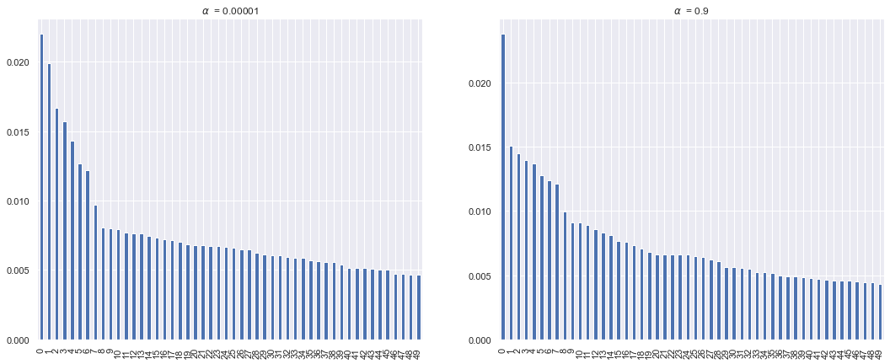

$\alpha$ controls the sparsity of document-topic loadings, which means if one document is made of one topic or more. $\eta$ controls the sparsity of topic-word loadings, which measures if one topic is represented by a small amount of words or a variety of words. We can find that $\eta$ changes the topic a lot, while $\alpha$ doesn't change the graph much. The reason could be that my topics have some cross-over and some of them have similar contents. So when we increase $\eta$, the probability of different words becomes similar, but when we increase $\alpha$, it doesn't change much.

## Dynamic Topic Modeling

|  |  |  |  |  |  |
| --- | --- | --- | --- | --- | --- |
| 2015 | 2016 | 2017 | 2018 | 2019 | 2021 |
| = | = | job | job | job | job |
| job | job | = | = | = | = |
| people | people | people | people | people | people |
| work | work | work | time | time | time |
| time | time | time | work | work | work |
| ask | ask | ask | ask | ask | ask |
| company | company | company | like | offer | offer |
| like | like | like | company | like | company |
| offer | offer | offer | offer | company | like |
| know | know | know | know | know | know |

|  |  |  |  |  |  |
| --- | --- | --- | --- | --- | --- |
| 2015 | 2016 | 2017 | 2018 | 2019 | 2021 |
| $ | $ | $ | $ | $ | $ |
| pay | pay | pay | pay | pay | pay |
| loan | loan | loan | loan | loan | car |
| year | year | year | year | car | year |
| month | month | month | month | year | loan |
| car | car | car | car | month | month |
| debt | debt | debt | debt | debt | debt |
| payment | payment | payment | payment | work | work |
| work | work | work | work | payment | payment |
| house | live | live | live | get | get |

|  |  |  |  |  |  |
| --- | --- | --- | --- | --- | --- |
| 2015 | 2016 | 2017 | 2018 | 2019 | 2021 |
| delete | delete | delete | delete | delete | delete |
| fund | fund | fund | remove | remove | remove |
| remove | remove | remove | fund | fund | fund |
| stock | stock | stock | stock | stock | stock |
| sell | sell | sell | sell | sell | sell |
| buy | buy | buy | buy | buy | buy |
| market | market | market | market | market | market |
| share | share | share | share | vanguard | vanguard |
| vanguard | vanguard | vanguard | vanguard | share | share |
| portfolio | portfolio | portfolio | portfolio | portfolio | portfol |

|  |  |  |  |  |  |
| --- | --- | --- | --- | --- | --- |
| 2015 | 2016 | 2017 | 2018 | 2019 | 2021 |
| $ | $ | $ | $ | $ | $ |
| year | year | year | year | year | year |
| money | money | account | account | account | account |
| account | account | money | money | money | money |
| tax | tax | tax | tax | tax | tax |
| saving | saving | saving | ira | ira | saving |
| 401k | ira | ira | 401k | 401k | 401k |
| income | 401k | 401k | saving | saving | ira |
| ira | income | income | invest | invest | invest |
| invest | invest | invest | roth | roth | roth |

|  |  |  |  |  |  |
| --- | --- | --- | --- | --- | --- |
| 2015 | 2016 | 2017 | 2018 | 2019 | 2021 |
| credit | credit | credit | credit | credit | credit |
| card | card | card | card | card | card |
| account | account | account | account | account | account |
| bank | bank | bank | bank | bank | bank |
| pay | pay | pay | check | check | check |
| get | check | check | pay | $ | $ |
| check | get | get | get | get | get |
| say | say | say | $ | pay | pay |
| $ | score | $ | say | score | score |
| score | $ | score | score | say | say |

# Vector Space and Word Embeddings

This part, we build on last part's topic modeling techniques by taking a text corpus we have developed, specifying an underlying number of dimensions, and training a model with a neural network auto-encoder (one of Google's word2vec algorithms) that best describes corpus words in their local linguistic contexts, and exploring their locations in the resulting space to learn about the discursive culture that produced them. Documents here are represented as densely indexed locations in dimensions, rather than sparse mixtures of topics (as in LDA topic modeling), so that distances between those documents (and words) are consistently superior, though they require the full vector of dimension loadings (rather than just a few selected topic loadings) to describe. We will explore these spaces to understand complex, semantic relationships between words, index documents with descriptive words, identify the likelihood that a given document would have been produced by a given vector model, and explore how semantic categories can help us understand the cultures that produced them.

## 5.1  CBOW(The Continuous Bag of Words) Model

Word2Vec needs to retain the sentence structure so as to capture a "continuous bag of words (CBOW)" and all of the skip-grams within a word window. The algorithm tries to preserve the distances induced by one of these two local structures. This is very different from clustering and LDA topic modeling which extract unordered words alone.

When we normalize here, we don't use the lematized form of the word because we might lose information. Note the paramter in the normalize tokens function.

CBOW

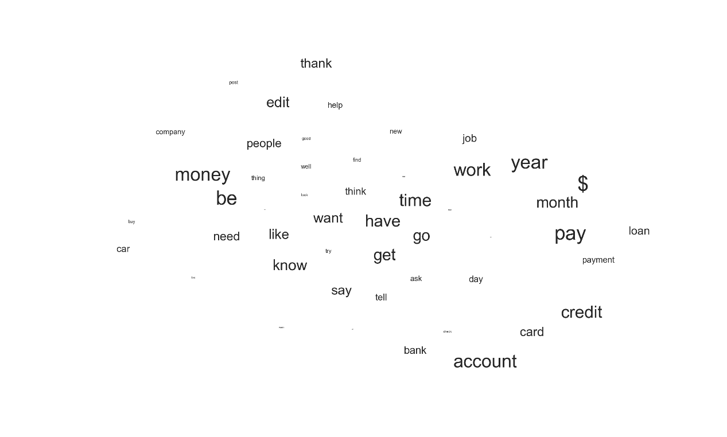

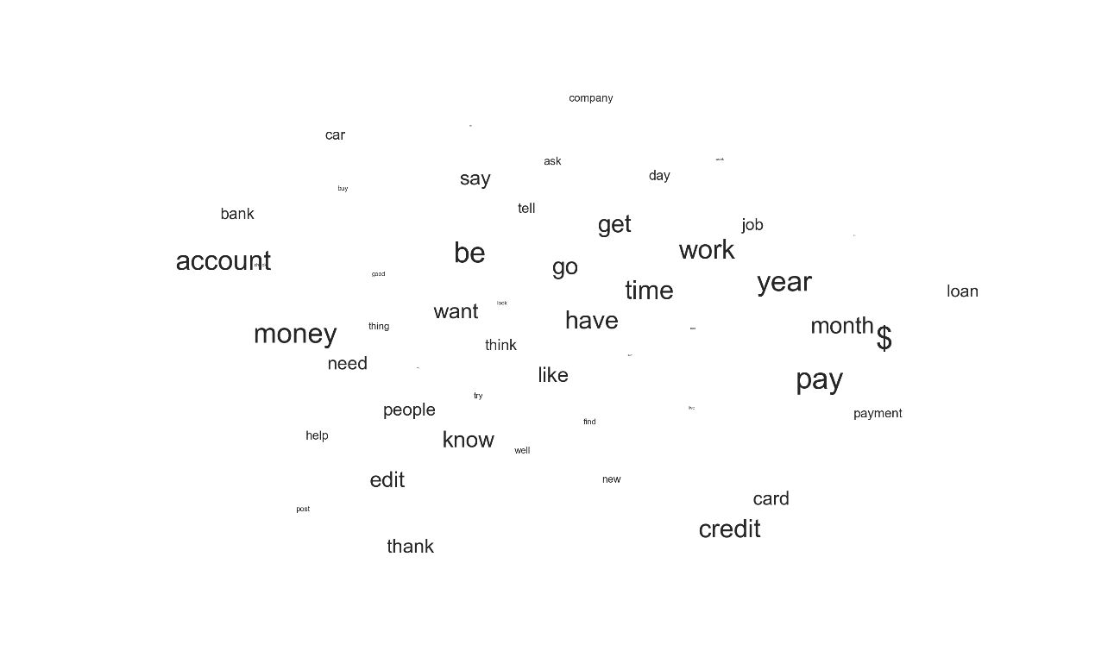

Skip gram

**What does this pattern reveal about the semantic organization of words in your corpora?**

We can find that the most different word in ['student', 'loan', 'debt', 'payment', 'account','investment', 'tax'] is 'investment'. Probabaly it's because investment is an action for people have extra money and relatively more affluent, but other words such as 'loan' 'debt' 'payment' are more for people who have more financial limitations.

For addition/subtraction, we got following relationships:

'pay' + 'debt' = 'loan' + 'payment'

'student' + 'loan' = 'pay' + '$'

'credit' + 'score' = 'account' + 'start'

'mortgage' + 'house' = 'lose' + 'refinance'

**Which estimation and visualization specification generate the most insight and appear the most robustly supported and why?**

I repeat the visualization several times (because the plot is kind of nondeterministic). Among them, 'payment', 'pay', 'credit', 'loan' are usually together. 'house' and 'mortgage' are side by side, as well as 'tax' and 'income'

Table 1 Most Similar Words to ‘finance’

|  |  |
| --- | --- |
| CBOW | SG |
| (domain, 0.9975020885467529) | (domain, 0.9038022756576538) |
| (core, 0.9973710775375366) | (core, 0.8971995711326599) |
| (economics, 0.9970412850379944) | (economics, 0.8908737897872925) |
| (introduction, 0.9942911863327026) | (tutorial, 0.8825550079345703) |
| (tutorial, 0.9941723942756653) | (personal, 0.8703951835632324) |
| (inflation, 0.9931447505950928) | (v, 0.8317123651504517) |
| (investment, 0.9930504560470581) | (introduction, 0.8269104957580566) |
| (v, 0.9929893016815186) | (investment, 0.8173561096191406) |
| (personal, 0.9928480386734009) | (vehicle, 0.8171368837356567) |
| (gain, 0.9927452206611633) | (inflation, 0.8123129606246948) |

Table 2 Most Similar Word to ‘loan’

|  |  |
| --- | --- |
| CBOW | SG |
| (pay, 0.9886571168899536) | (student, 0.947920560836792) |
| (interest, 0.986750602722168) | (forgiveness, 0.9250237345695496) |
| (payment, 0.9842690229415894) | (program, 0.9044044613838196) |
| (student, 0.982388973236084) | (borrower, 0.8913569450378418) |
| (month, 0.9769452810287476) | (qualify, 0.8813320398330688) |
| ($, 0.9758726358413696) | (graduate, 0.8758156299591064) |
| (debt, 0.975852370262146) | (forgive, 0.8746172189712524) |
| (rate, 0.9507907629013062) | (consolidate, 0.8732489347457886) |
| (year, 0.9503719806671143) | (repay, 0.8646396398544312) |
| (car, 0.9470028281211853) | (discharge, 0.8627040982246399) |

Table 3 Most Similar Word to ‘house’

|  |  |
| --- | --- |
| CBOW | SG |
| (home, 0.9981556534767151) | (cheap, 0.9140413999557495) |
| (make, 0.9973364472389221) | (home, 0.90831458568573) |
| (buy, 0.9973288774490356) | (own, 0.8955202102661133) |
| (expense, 0.9969913959503174) | (sell, 0.893168032169342) |
| (college, 0.9969626665115356) | (rent, 0.8855429887771606) |
| (old, 0.9969006180763245) | (buy, 0.8843915462493896) |
| (plan, 0.996694803237915) | (nice, 0.8827567100524902) |
| (school, 0.9964942336082458) | (clothe, 0.879166841506958) |
| (price, 0.9963560700416565) | (car, 0.8713674545288086) |
| (cost, 0.9963399171829224) | (reliable, 0.8700470924377441) |

Attentions: We have different columns:

'tokenized_text',

'normalized_tokens',

'reduced_tokens',

'tokenized_sents',

'normalized_sents',

'tokenized_words',

'normalized_words'

# D2V

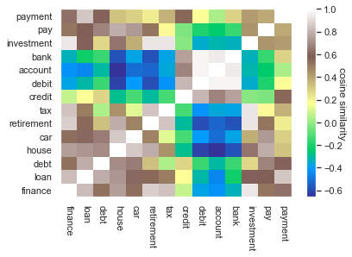

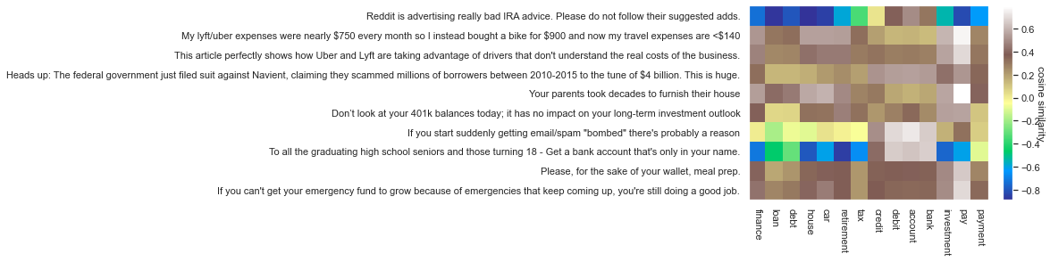

We have some positive as well as negative correlations.

What does this pattern reveal about the documentary organization of your semantic space?

## 5.4 Projections

Create 2 dimensions

|  |  |  |
| --- | --- | --- |
|  | positive | negative |
| family | ['mom','parent','father','dad','mother'] | ['son','daughter','child'] |
| financial status | ['loan','debt','poor','unemployment'] | ['saving','investment','rich','job'] |

Words to project:

tax: 'tax', 'income', 'salary', 'earn',

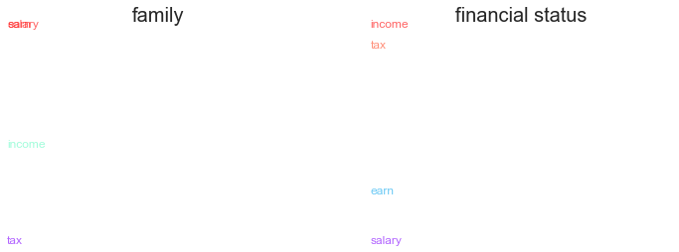

retirement: 'retirement', '401k', 'ira', 'young', 'money'

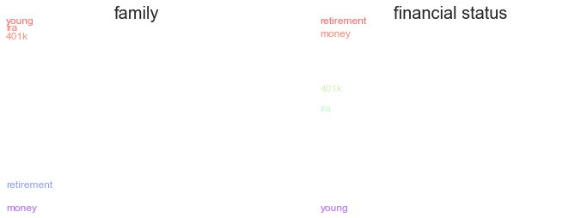

Interpretation:

Which of the dimensions you analyze explain the most variation in the projection of your words and why?

Family dimension explains the most variation in the 'retirement' word list, because the concept of family is more related to retirement (for example, we may care our parents' retirement.) Financial status explain the most variation in 'tax' dimension, maybe because tax is more related to finance compared to family.

Discussions

Generalization Bias--most users of online platforms are young people who are used to the internet. Middle-age people may not be willing to disclose their financial concerns online.

**Alternatives:**

Other discussion websites.

Methods to scale up my sample

I can broaden my dataset by scale up the time period to include more articles from myFICO Forums, YNAB Forums, Morningstar Forums, Reddit–Investing, Bogleheads Forum, Fat Wallet Forums, and Bigger Pockets Forum.

# Reference

scipy.cluster.hierarchy.linkage https://docs.scipy.org/doc/scipy/reference/generated/scipy.cluster.hierarchy.linkage.html#scipy.cluster.hierarchy.linkage

References:

Reddit. (2021). *Personal Finance Wiki* https://www.reddit.com/r/personalfinance/wiki/index

Researve, F. (2018). Report on the Economic Well-Being of U.S. Households in 2017. (Reprinted.